**Python Installation Guide**

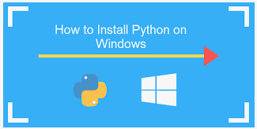

**Please read the following videos (Please respect the order)**

1. **Installing Python**

<https://youtu.be/PHloUu54C4s>

1. **Installing PyCharm**

<https://youtu.be/t0OeJlIrDts>

1. **Installing Modules/Packages**

<https://youtu.be/m9d5-WZ3a14>